**MERCHANT ONBOARDING – USER STORIES**

After you have logged into the Maybank API Portal site and enter the dashboard portal dashboard page, click on **EIP** tab and choose **Merchant Onboarding** button. You will see 2 option, which are **Partner Onboarding** and **Internal Channel Onboarding.**

**(Use Case 1) - First time user for Partner Onboarding.**

1. When you click on **Partner Onboarding** option. For first time user, you will be directed to the ‘**Entity Details**’page. You will be required to fill in your business details in the form.

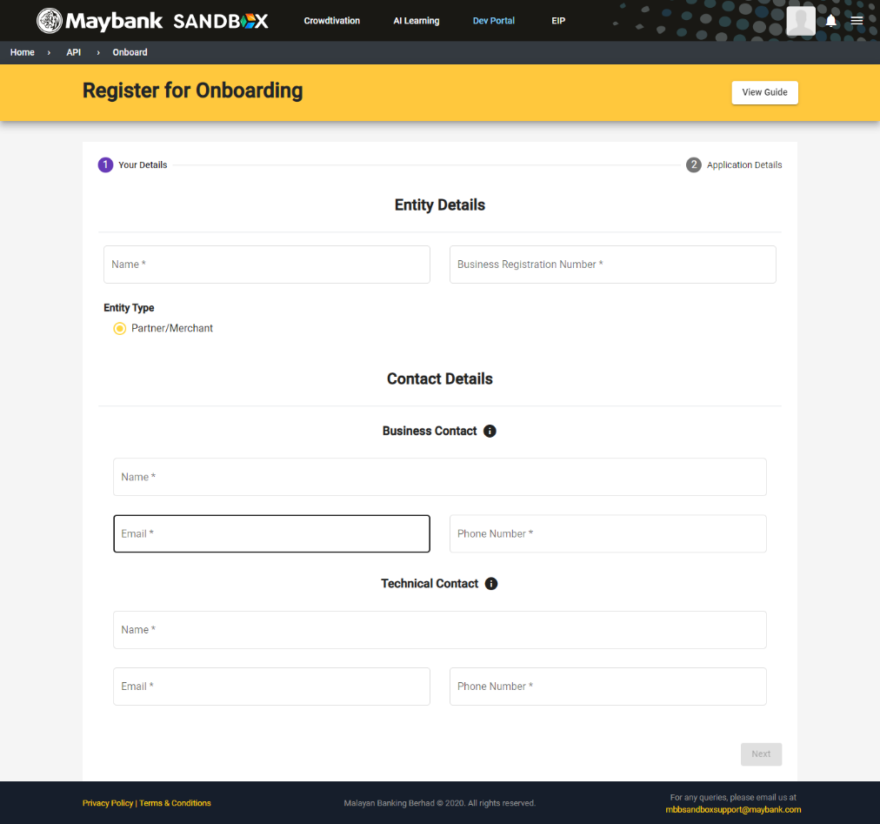

1. After completing the form, click ‘**Next**’. You will be directed to the next page which is the ‘**Application Details**’ page. Fill in the form accordingly and click ‘**Next**’.

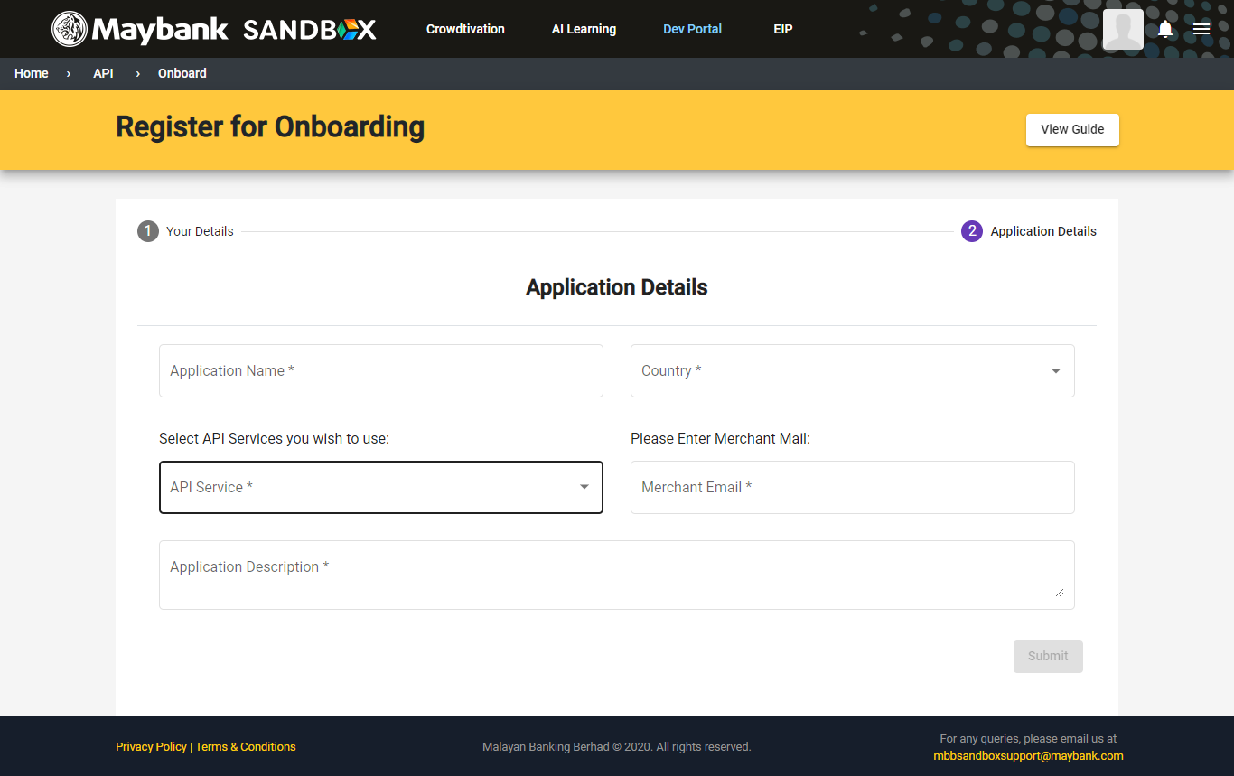

1. After clicking ‘**Next**’, you will be directed back to the dashboard and you will see the application details.
2. In the case of **Pending Public Key**, you are required to upload your public key for admin approval.

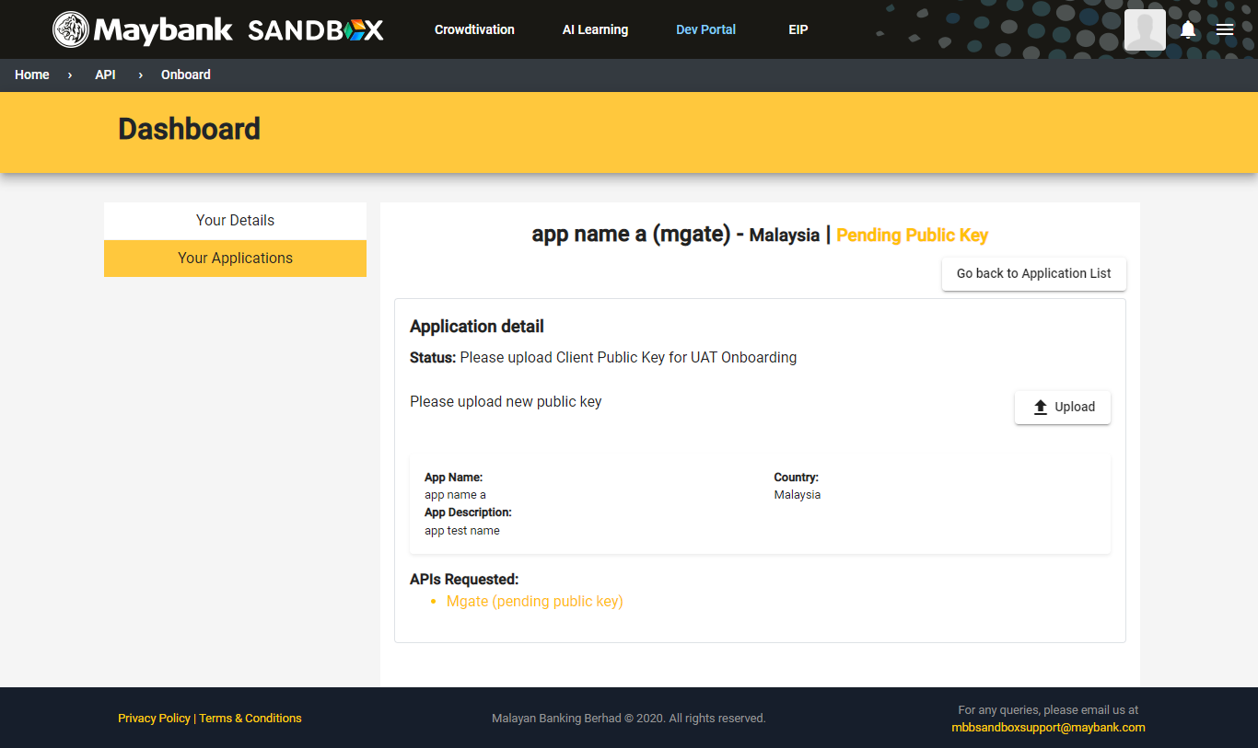

1. After uploading all the required documents, your merchant onboarding request will change to ‘**Pending’** for the admin to approve.

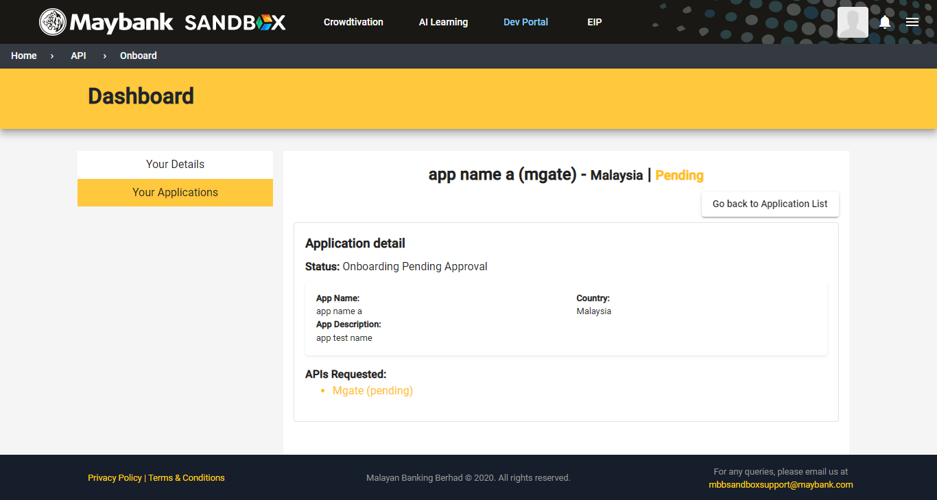

1. After the request has been approved by admin, the request status will change to ‘**UAT**’ as the application are currently in user acceptance testing (UAT) progress.

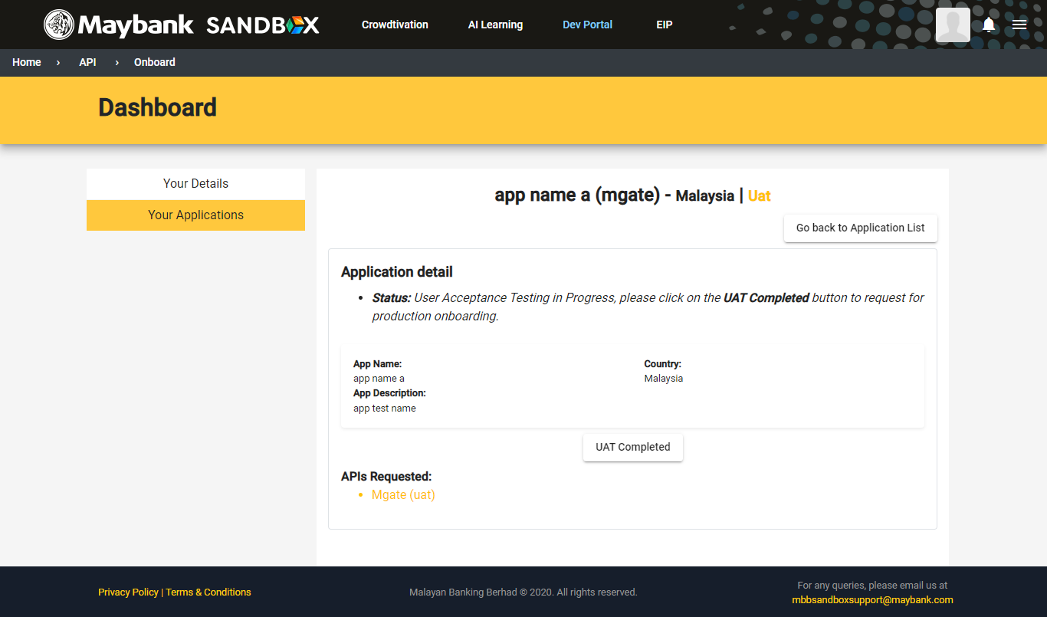

**Use Case 2) - Registered user for Partner Onboarding.**

1. When you click on **Partner** **Onboarding** option. For registered user, you will be directed to ‘**Your** **Detail’** tab in ‘**Dashboard**’page. You will see your **Entity Details**, **Primary Business Contact Details** and **Primary Technical Contact Details**.

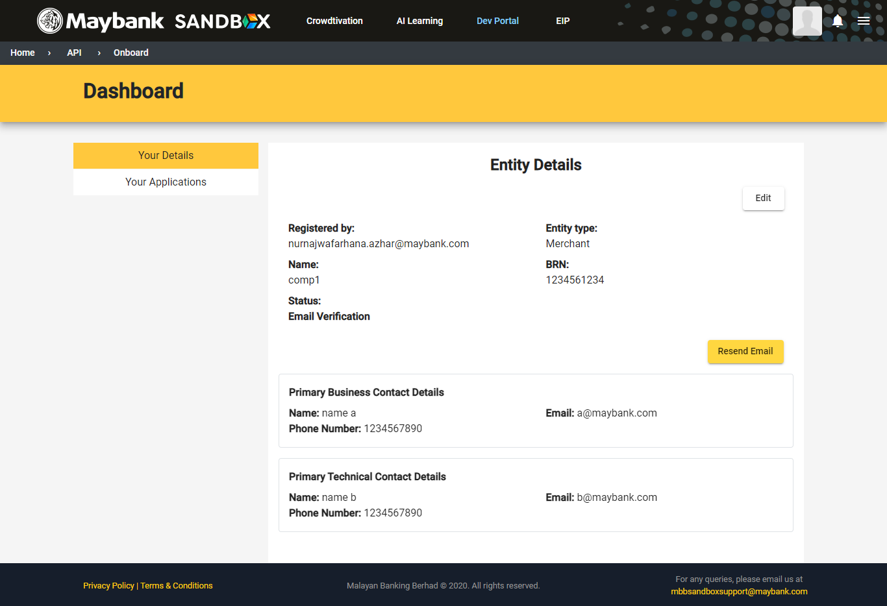

1. To register new application, go to the ‘**Your Application’** tab in the dashboard page and click on the ‘**Register New Application’** button.

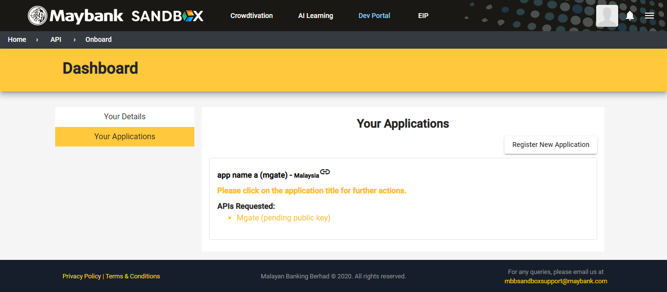

1. You will be directed to the next page which is the ‘**Application Details**’ page. Fill in the form accordingly and click ‘**Next**’.

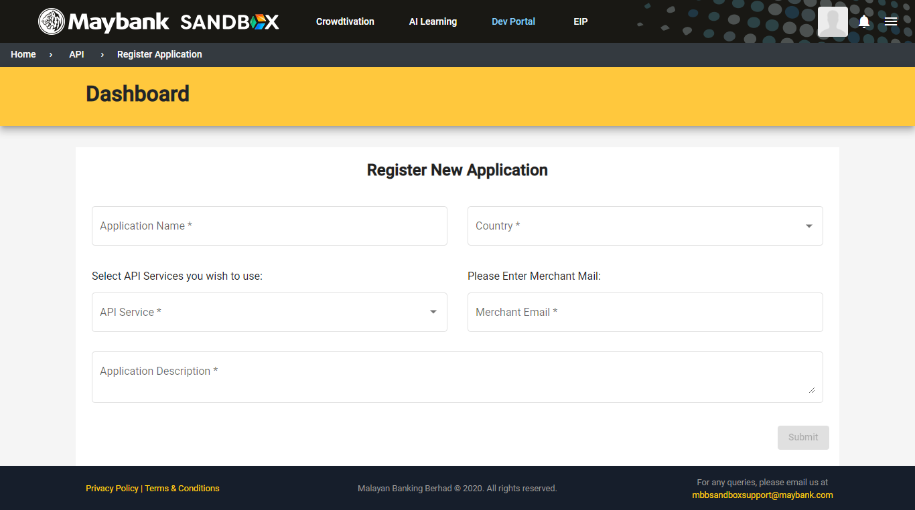

1. After clicking ‘**Next**’, you will be direct back to the dashboard and you will see the application details.
2. In the case of **Pending Public Key**, you are required to upload your public key for admin approval.



1. After uploading all the required documents, your merchant onboarding request will change to ‘**Pending’** for the admin to approve.



1. After the request has been approved by admin, the request status will change to ‘**UAT**’ as the merchant are currently in user acceptance testing progress.



**(Use Case 3) - Internal Channel Onboarding.**

1. Click on Internal Channel Onboarding. You will be direct to the Channel Onboarding dashboard page. In the page, for normal user, you will see **Channel Service Rejected List** and **Channel Service List**. However, for Admin user, you will see **Channel Service Pending Approval List** and **Channel Service List**.

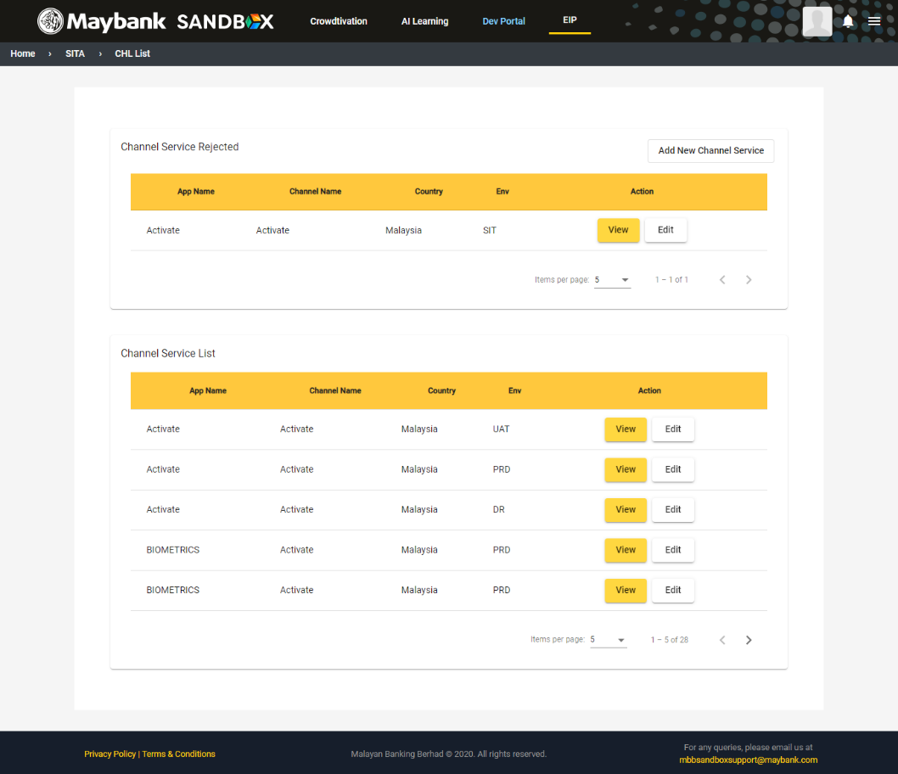

For Normal User

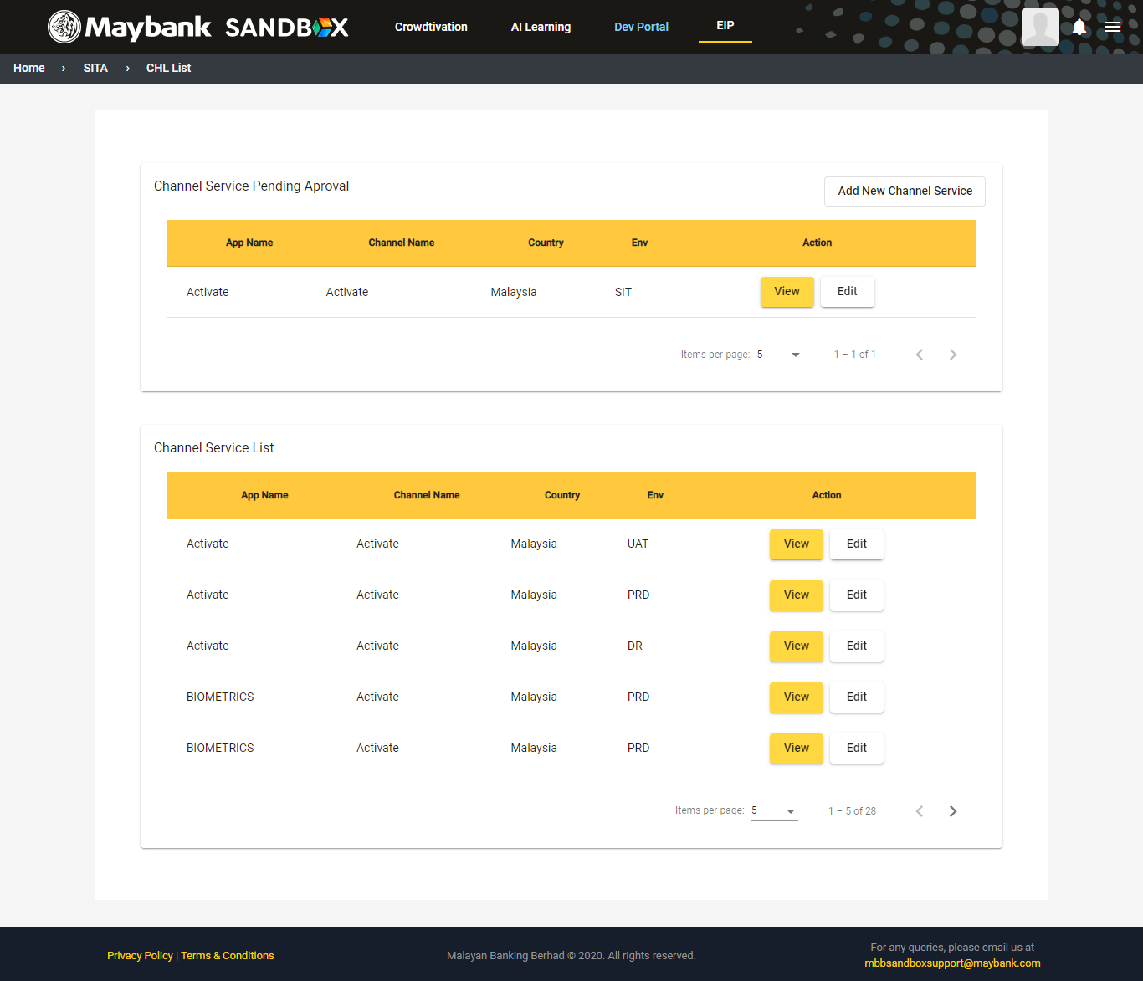

For Admin User

1. To add new service, click on **Add New Channel Service** button and fill in the form accordingly.

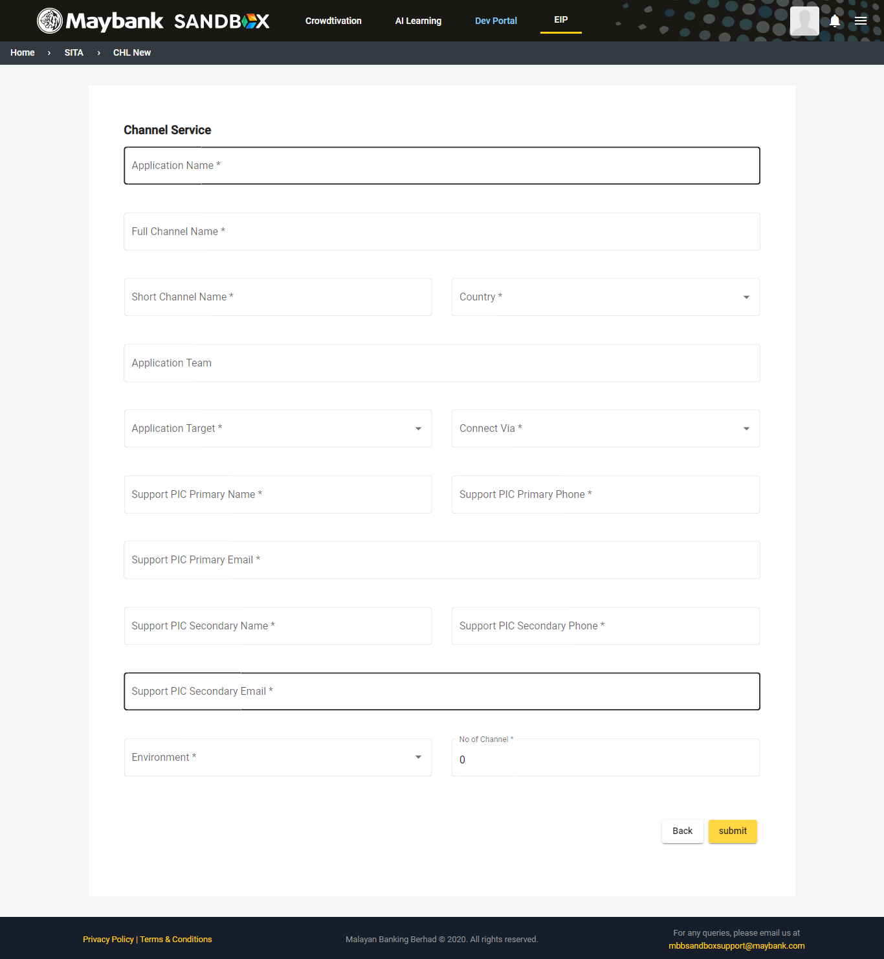

1. After completing the form, click on ‘**Submit’** button and you will be directed back to the dashboard.
2. On the dashboard page, in the channel service list, you click on the ‘**View**’ action button. You will then be able to view your **Channel Details**.

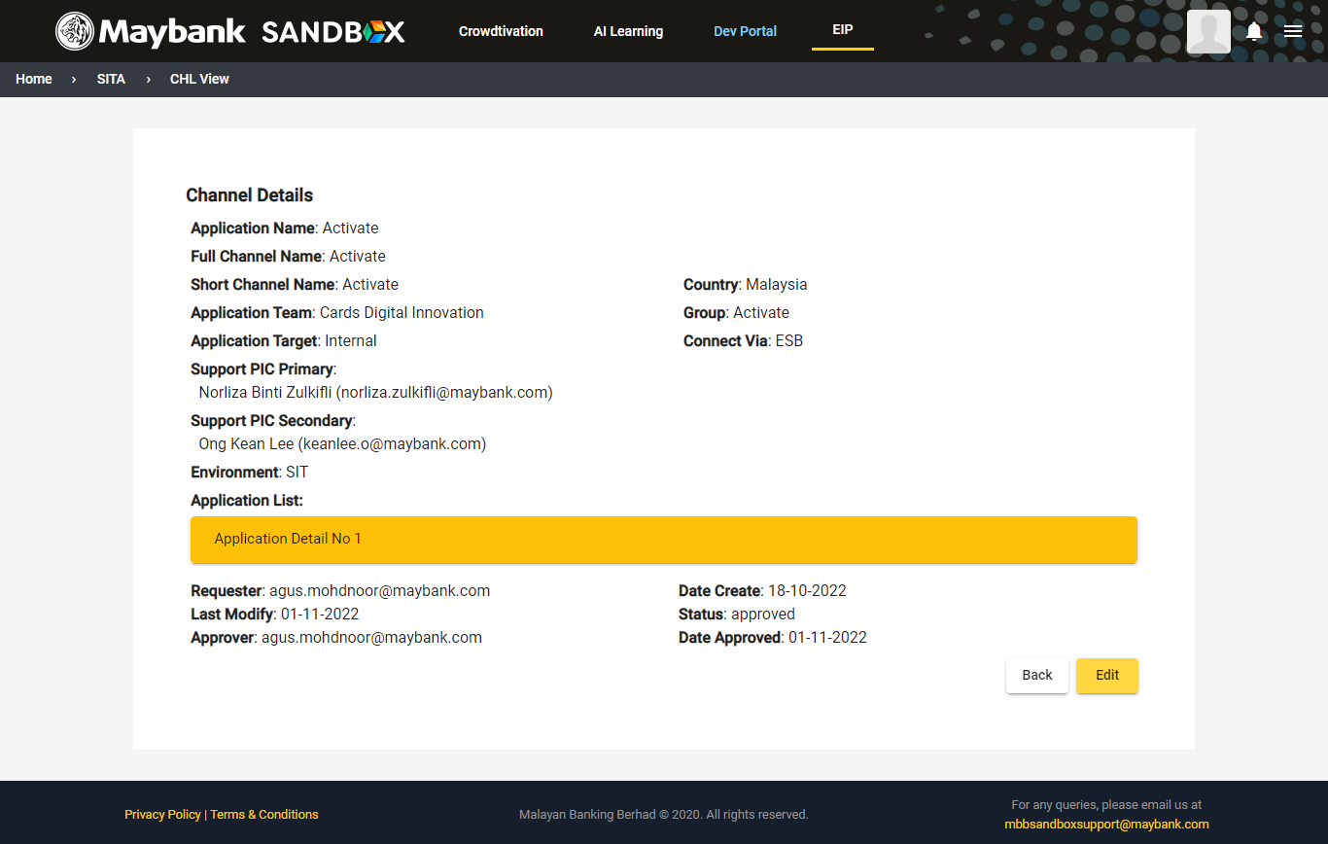

1. You can edit your Channel Details by clicking on the ‘**Edit**’ button.
2. For **Admin** user, when you click on the ‘**View**’ action button, you can view your **Channel Details** and as for the ‘**Pending**’ status channel, you will see **Reject** and **Approve** action button.

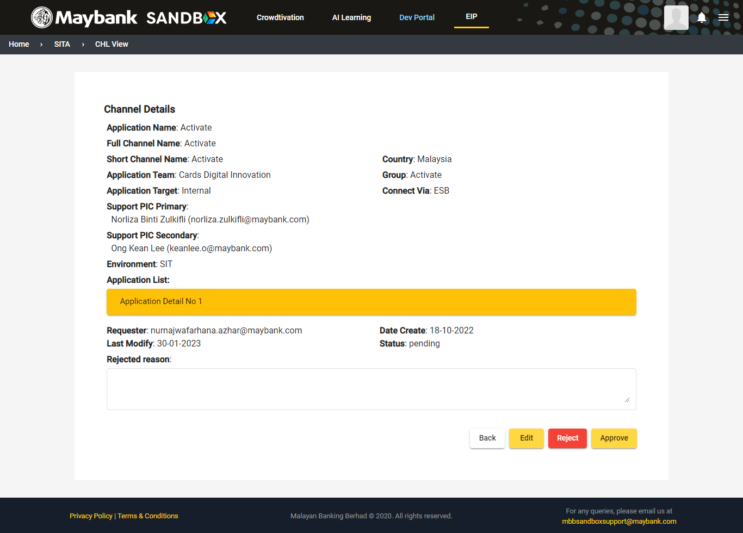

1. If the merchant onboarding request is still in pending status, you will see ‘**Pending’** status in the merchant details and if your request is approved by the Admin, you will see the ‘**Approved’** status in the merchant details page.